

PLEXTOR PTX1 PLAYER QUICK USE GUIDE

Powering On/Off
- The Power ON/OFF button is the large round button on the far right of the unit’s face.
- To turn the power on or off, press the Power ON/OFF button and hold for two seconds, then release.

Inserting/Ejecting a CD
- On the front of the player, you will find the CD Insertion/Ejection Slot.
- To insert a CD into the player, push it into the slot. Once the CD has been inserted approximately three quarters of the way in, the CD is loaded automatically.
- To eject a CD, simply press the square EJECT button located in the bottom right-hand corner on the top face.

Playing and Stopping a CD
- The PLAY/STOP button is the big rectangular button just above the CD Insertion/Ejection Slot. Stopping acts just like pausing a CD.
- To the left of the PLAY/STOP button is the REWIND button and to the right is the FAST FORWARD button.

Changing the Tone and Volume
- The TONE & VOLUME buttons are the two toggle buttons located side by side at the top, centre section of the player’s face.
- Pressing the top of each button will increase the tone or volume and pressing the bottom of each button will decrease the tone or volume.
Diagram of the Plextor PTX1 Pro DAISY Player
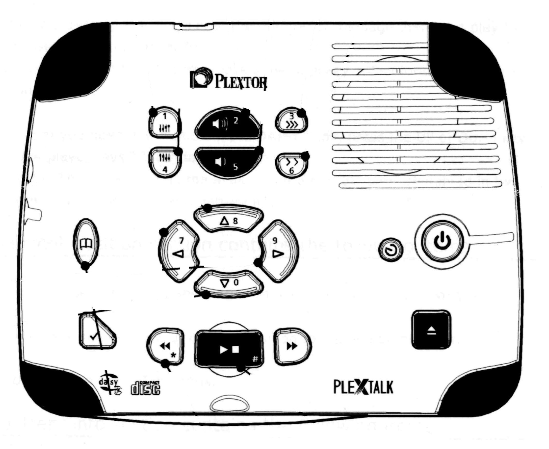
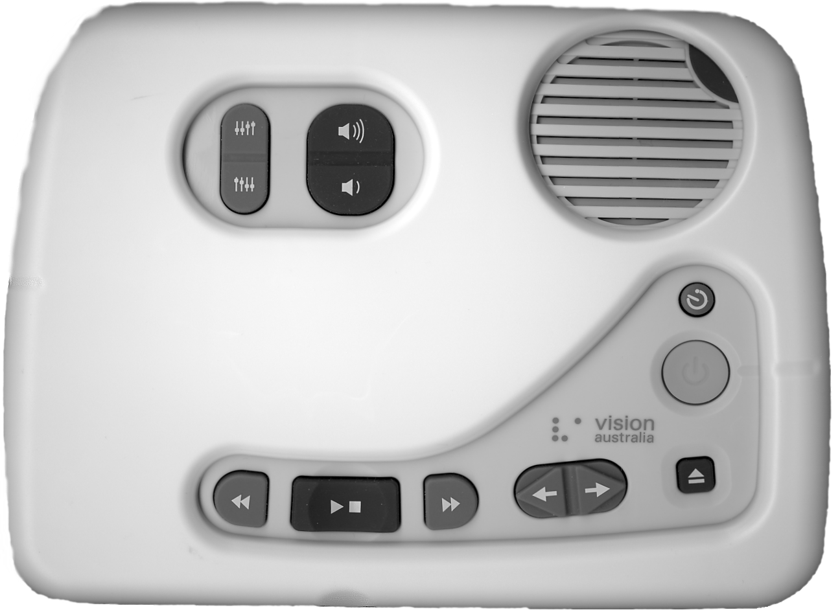
CD Insertion/Ejection Slot
Speaker
Power
Eject
Sleep Timer
Tone
Volume
Rewind
Play/Stop
Fast Forward
USB port
Headphone Jack
LAN socket
SD Card port
Title toggle
Power Plug

