

PLEXTOR WI-FI PLAYER QUICK USE GUIDE

Powering On/Off
- The Power ON/OFF button is the large round button on the far right of the unit’s face.
- To turn the power on or off, press the Power ON/OFF button and hold for two seconds, then release.

Inserting/Ejecting a CD
- On the front of the player, you will find the CD Insertion/Ejection Slot.
- To insert a CD into the player, push it into the slot. Once the CD has been inserted approximately three quarters of the way in, the CD is loaded automatically.
- To eject a CD, simply press the square RETURN/EJECT button located in the bottom right-hand corner on the top face.

Playing and Stopping a CD
- The PLAY/STOP button is the big rectangular button just above the CD Insertion/Ejection Slot. Stopping acts just like pausing a CD.
- To the left of the PLAY/STOP button is the REWIND button and to the right is the FAST FORWARD button.

Changing the Tone and Volume
- The TONE & VOLUME buttons are the two toggle buttons located side by side at the top, centre section of the player’s face.
- Pressing the top of each button will increase the tone or volume and pressing the bottom of each button will decrease the tone or volume.
Diagram of the Plextor Wi-Fi DAISY Player
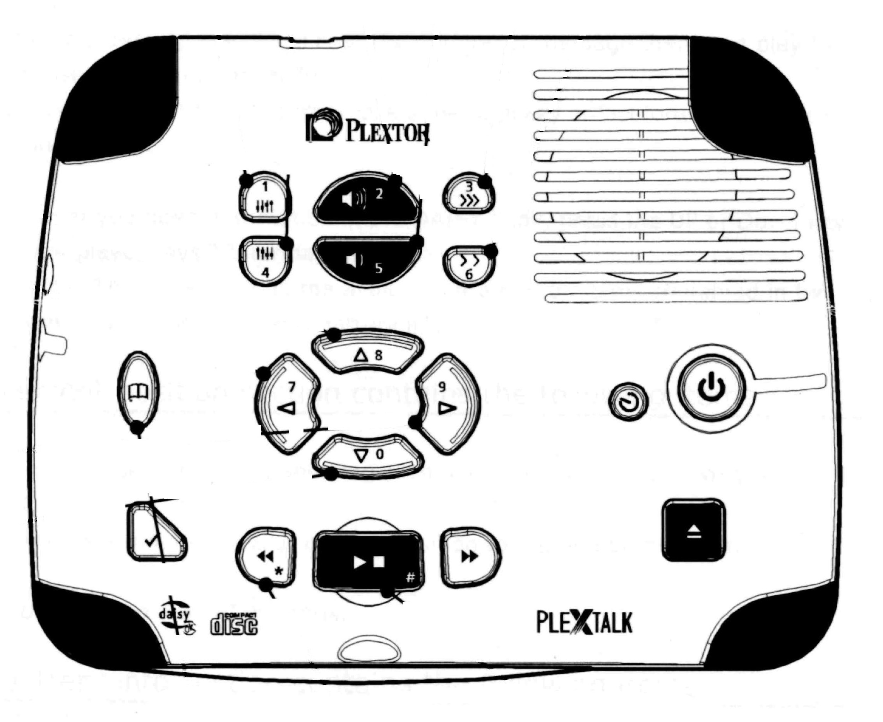
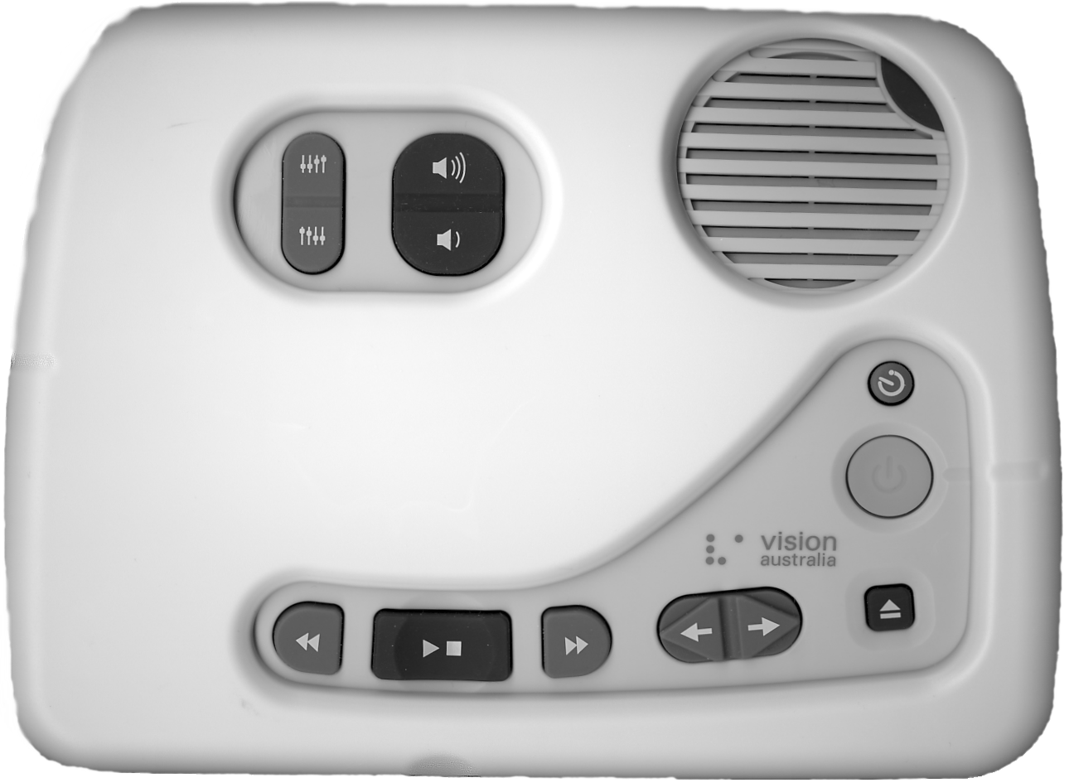
CD Insertion/Ejection Slot
Speaker
Power
Return/Eject
Sleep Timer
Tone
Volume
Rewind
Play/Stop
Fast Forward
USB port
Headphone Jack
LAN socket
SD Card port
Title toggle
Power Plug

